(Artificial Intelligence)

AI Assistance in Implement Client Script & UI Policy (Incident) — ServiceNow

1. Overview
This project — Implement Client Script & UI Policy (Incident) — was built to enforce data integrity on the Incident table using rule-based, client-side controls: UI Policies, UI Policy Actions, and onChange, onSubmit, and onCellEdit Client Scripts. These controls are deterministic — they follow fixed "if this, then that" logic written by a developer.
ServiceNow's platform, however, does not stop at rule-based automation. The same Now Platform that hosts these UI Policies and Client Scripts also carries built-in Artificial Intelligence capabilities. This document looks at how AI shows up on the very form used in this project, and how it could be combined with the rules already configured here.

2. Objective of This Section
The objective here is not to rebuild the project using AI, but to (a) identify where ServiceNow's existing AI features are already visible on the Incident form used in this project, (b) explain how they differ from and complement the rule-based UI Policy/Client Script approach, and (c) outline realistic ways this project could be extended with AI in the future.

3. Rule-Based Logic vs. AI-Driven Logic
Before looking at where AI appears, it helps to contrast the two approaches used side by side on the same Incident form:
- Rule-based (this project): fixed conditions written by a developer — e.g., "If Impact is 1 - High, make Assignment Group mandatory and Urgency read-only." The logic never changes unless someone edits the script or policy.
- AI-driven (platform feature): the system analyzes the data typed into the form (like the Short Description) and dynamically decides what to suggest, without anyone hard-coding every possible case.
The screenshot below shows the rule-based side — the UI Policy condition that drives the mandatory and read-only behavior used throughout this project.
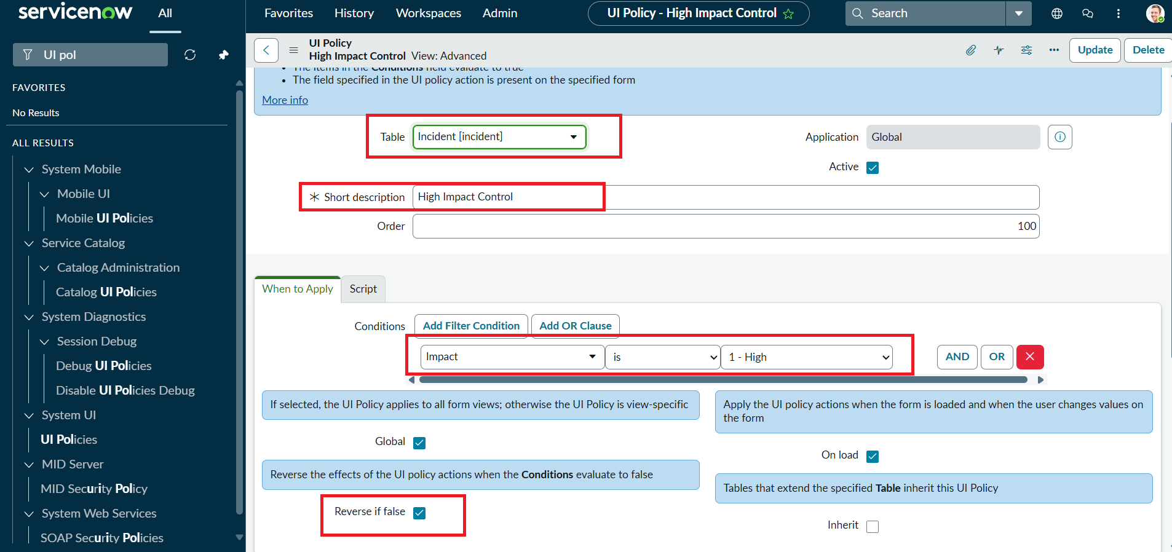
UI Policy condition (Impact is 1 - High) — the deterministic, rule-based side of the project

4. Where AI Appears on the Same Form
On the Incident form used for testing, the "Related Search" panel is powered by Knowledge & Catalog (AI). As soon as a Short Description is entered, the platform automatically searches knowledge articles, catalog items, and related records using AI-based relevance matching — without the agent typing a separate search query.
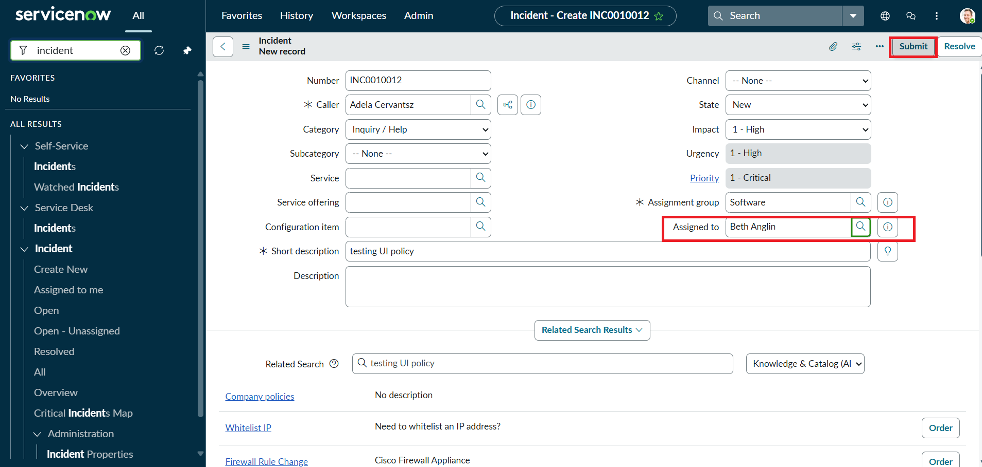
Incident form showing the AI-powered "Related Search" panel (Knowledge & Catalog (AI)) next to the fields governed by the UI Policy and Client Scripts
In the screenshot above, typing "testing UI policy" as the Short Description caused the AI search to surface related knowledge results (Company policies, Whitelist IP, Firewall Rule Change) automatically — helping the agent find relevant information while the same form still enforces the Impact-based mandatory and read-only rules built in Tasks 1–5.
The same AI-powered panel is present even on the validation screen, confirming it runs independently of whether the onSubmit script blocks the save or not:
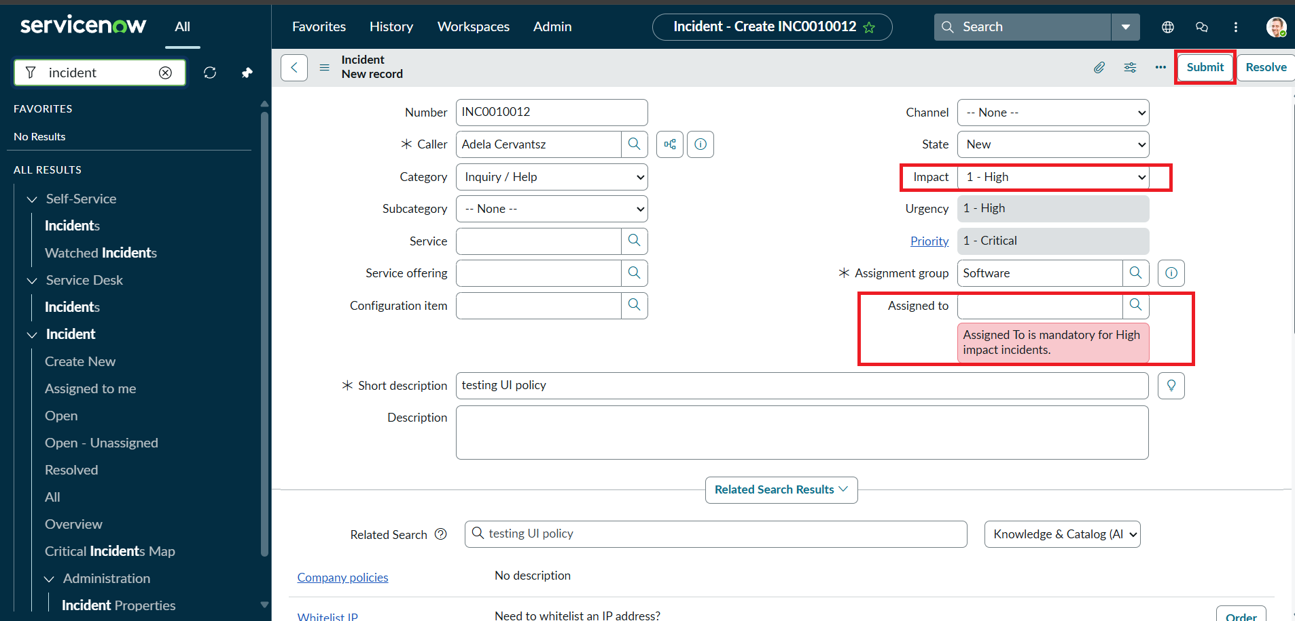
The Knowledge & Catalog (AI) related search panel still available even while the onSubmit script blocks the save for a missing Assigned To

5. How AI Complements the Client Scripts & UI Policies
- UI Policies/Client Scripts handle deterministic rules — e.g., "if Impact is High, make Assignment Group mandatory."
- The AI-driven Related Search adds a layer of intelligent assistance — suggesting knowledge articles and catalog items relevant to the incident text, without any manual configuration.
- The onChange script (Task 3) auto-sets Urgency using a fixed rule; an AI model could eventually make the same kind of prediction from more signals (description text, caller history, past incidents) instead of one hard-coded condition.
- Together, rule-based logic and AI-assisted suggestions combine enforced data integrity with intelligent agent guidance on the same form.

6. Broader AI Capabilities on the Now Platform
Beyond the Related Search panel visible in this project, ServiceNow offers several other AI capabilities that are relevant to Incident management and could build on the foundation created here:

Predictive Intelligence
Uses machine learning models trained on historical Incident data to automatically predict field values such as Category, Assignment Group, or Priority based on the text entered in Short Description — reducing manual selection and complementing the mandatory-field rules already enforced by the UI Policy.

Now Assist (Generative AI)
Can summarize long Incident descriptions and work notes, draft resolution notes, and suggest next steps for the agent — useful on High impact Incidents where the UI Policy already demands complete, accurate data.

Virtual Agent
A conversational AI layer that could prompt the caller for missing mandatory information — such as Assigned To or a clear description — before the Incident is even created, reducing the number of records that get blocked by the onSubmit validation script.

AI Search
The same technology behind the Related Search panel shown earlier; it can be extended platform-wide so agents and end users find relevant knowledge, catalog items, and past Incidents using natural language instead of exact keyword matches.

7. Possible AI Extensions for This Project
- Predictive Intelligence could auto-suggest Impact, Urgency, or Category based on the Short Description, reducing manual selection.
- AI Search/Predictive Intelligence could recommend the correct Assignment Group automatically, complementing the mandatory field enforced by the UI Policy Action.
- Virtual Agent could ask the caller for missing mandatory details (like Assigned To) before the Incident is even submitted, reducing onSubmit validation failures.
- Now Assist could draft a short summary or suggested resolution note automatically once a High impact Incident is assigned.

8. Benefits and Considerations
Benefits: AI features reduce manual effort, surface relevant knowledge instantly, and can make smarter, data-driven suggestions than a fixed script. Considerations: AI suggestions are probabilistic, not guaranteed — they should support, not replace, the deterministic UI Policy and Client Script rules that guarantee mandatory fields are always enforced. A blended approach (rules for compliance, AI for assistance) is the most reliable path forward for this project.

9. Conclusion
This project shows that even a lightweight, script-based solution on the Incident form already coexists with ServiceNow's built-in AI capabilities. The Related Search (Knowledge & Catalog AI) feature works alongside the UI Policy and Client Scripts to give agents both enforced data quality and intelligent, AI-assisted suggestions — with clear room to extend further using Predictive Intelligence, Now Assist, or Virtual Agent in future iterations.

